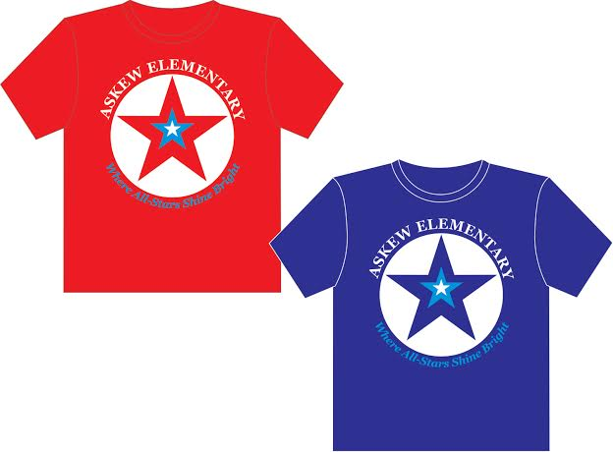
All-Star T-shirts

Askew T-shirts may be used as part of the school uniform.

Size | Price | Quantity-Red | Quantity-Navy | Total($)
Youth Small | $10.00 | ______ | ______ | _____
Youth Medium | $10.00 | ______ | ______ | _____
Youth Large | $10.00 | ______ | ______ | _____
Adult Small | $10.00 | ______ | ______ | _____
Adult Medium | $10.00 | ______ | ______ | _____
Adult Large | $10.00 | ______ | ______ | _____
Adult X-Large | $10.00 | ______ | ______ | _____
Adult XX-Large | $12.00 | ______ | ______ | _____
Adult XXX-Large | $12.00 | ______ | ______ | _____
 |  |  | T-shirt Total | $_____

Qty ____ X $10.00 ________
Qty ____ X $12.00 ________

Grand Total Enclosed: $__________________

Parent Name: ______________________________________________________

Student Name: _____________________________________________________

Teacher: _____________________________ Grade: ________

Phone Number: _______________________________________________

Please return this form to your child’s teacher along with your check made out to “Askew PTO”.
All pre-orders must be received by Sept 13th.
Pre-ordered items will be sent home with your child next week.

